**World War I Propaganda**

**prop·a·gan·da**

[prop-uh-gan-duh]

–noun

1. information, ideas, or rumors deliberately spread widely to help or harm a person, group, movement, institution, nation, etc.

2. the deliberate spreading of such information, rumors, etc.

3. the particular doctrines or principles propagated by an organization or movement

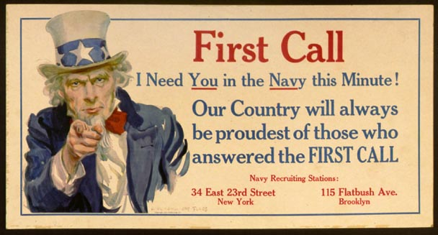

Use <http://staff.imsa.edu/socsci/jvictory/help_07/exemplary_papers/chang_3_ww1/steps_cpi.htm> to answer the questions below. Answer questions in the activities section of your binder on a separate sheet of paper.

1. What is the CPI and which president created it?
2. How were economics involved with the US stance on WWI?
3. The president changed his mind about the war in his second term. How did his stance change and how did the nation react to this “change of heart?”
4. What specific agenda did the CPI have?
5. How did the CPI use the media to convey its message?
6. Why was it important for the US government to have the people support WWI?

Use <http://www.washingtonpost.com/wp-dyn/content/article/2008/10/02/AR2008100204223_pf.html> to answer the following:

1. Where is propaganda being used overseas?
2. What is the main goal of this propaganda?
3. Is the US allowed to use propaganda on its own citizens?