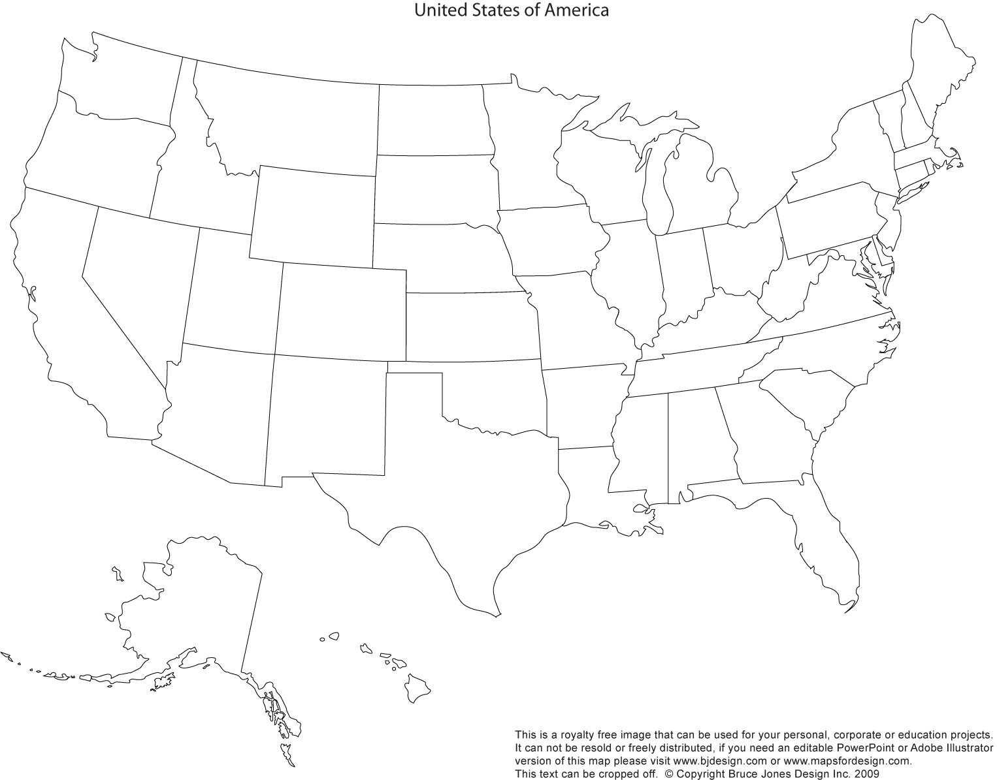

**KEY**

**Population Population Density**