The Politics of Prosperity
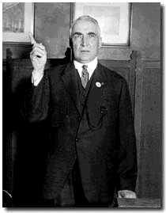
In search of prosperity, Americans elected three Republican Presidents during this decade. Each of these men promised to promote the prosperity through politics.

Warren G. Harding (1865-1923). Elected to the Presidency in the 1920s, Harding urged a "return to normalcy." He called for an end to the reform movements of the Progressive Era. The policies of his administration were generally conservative; he decreased taxes, raised tariffs, restricted immigration, limited labor rights, and decreased regulation for business. Harding's administration was marked by corruption and scandal.

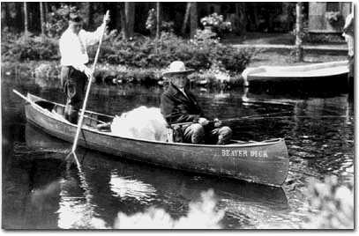

Calvin Coolidge (1872-1933). Coolidge did little as Warren G. Harding's vice president (1921-23), but he assumed the presidency after Harding's death. Many of Coolidge's policies, including federal tax cuts and high tariffs, were very popular during his presidency, but lost favor during the Great Depression.

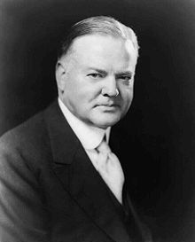

Herbert Hoover (1874-1964). Having served as secretary of commerce under both Harding and Coolidge, Hoover was elected to the presidency in 1928, helped by the prevailing prosperity in the country. He continued the conservative and business-friendly policies of Harding and Coolidge. Hoover had been in office just a few months when the Great Depression began. In 1932, he lost the presidential election to Franklin D. Roosevelt.

The Economic Boom of the 1920s
On the whole, the United States economy experienced steady growth and expansion during the 1920s. There were five main sources of the 1920s economic boom:
- New technology.
- Factory Efficiency
- Rapid increase in worker productivity
- Psychology of consumption
- Relations between the federal government and big business

1. New Technology.
During the WWI, a significant labor shortage, combined with the need for increased production, necessitated new, more efficient methods of production. The War stimulated a number of old industries, such as petroleum and steel, and helped create many new industries, such as plastic and rayon production. Money spent on new machinery for industry greatly increased. In 1915, the total annual spending was $600 million, which grew to $2.5 billion by 1918.

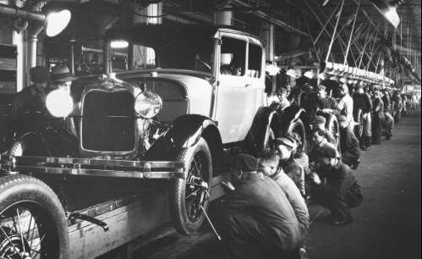
2. Factory Efficiency.
Efficiency in factories meant using mathematical formulas for workers, streamlining tasks, and increasing production. Henry Ford’s assembly line process greatly increased productivity and cut costs. In the 1920s, American industries implemented scientific management on a grand scale, pouring millions of dollars into research to make factories more efficient.

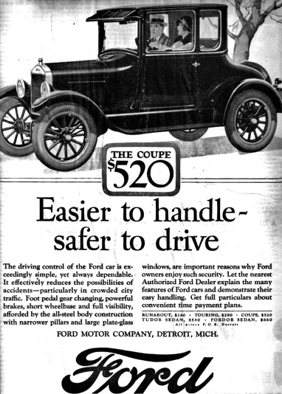

3. Rapid increase in worker productivity.
As factory efficiency and new technology increased worker productivity, workers earned higher wages and became better consumers. A new innovation appeared: the installment plan, which encouraged Americans buy products on credit (buy now – pay later).

4. Rapid increase in consumerism (buying lots of stuff)
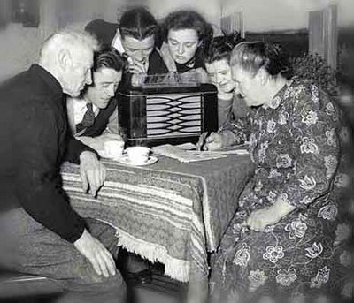
Americans began buying lots of products – even if they couldn’t afford the products, Americans bought them on credit. Examples of products consumers tended to purchase include:

A. Radios
By 1922, 3 million American households had radios, and purchases of receivers had increased by 2,500%, giving the industry annual sales of $850 million by 1929.

B. Movies
Motion picture production became one of the ten largest industries in the United States during the 1920s. In 1922, theaters sold 40 million tickets a week. By 1929, that number had grown to 100 million a week. One of the capitalists who cashed in on Hollywood was Joseph P. Kennedy, father of President John F. Kennedy, one of the nation's most influential political families. During eight months in Hollywood, he made $6 million.

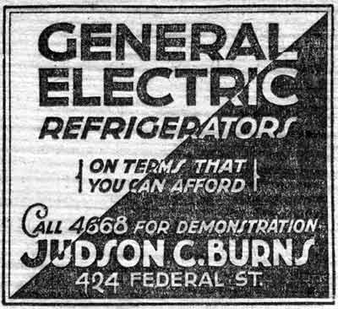
C. Household Appliances
A ton of new electric appliances lightened the load of the middle-class American housewife: vacuum cleaners, toasters, washing machines, refrigerators. Women became America's greatest consumers, purchasing appliances and other items that would have been considered a luxury just a generation before.

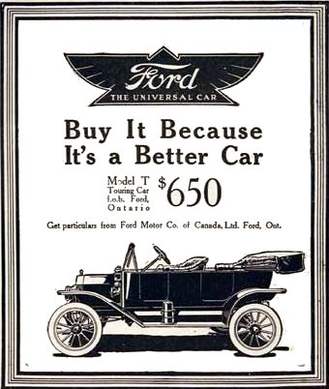
D. Automobiles
Annual automobile production rose from 2 million during the 1920s to 5.5 million in 1929. By the late 1920s, there was one automobile for every five Americans, allowing, theoretically, for every person in the United States to be on the road at the same time.
Two factors led to the rising popularity of cars:
- Cost-- The price of automobiles declined steadily until the mid-1920s so that many well-paid working families could now afford to purchase a car. The Model T Ford, for example, cost just $290 in 1926.
- Credit-- In 1925, 75% of all automobile were purchasds on credit.

5. The Federal Government Supported Big Businesses
The Republican-led government began to decrease regulation on businesses – allowing business owners to run their businesses without interference from the government. The government also relaxed its control over the stock market.

There were four major ways in which the federal government supported big business.

- Increased Tariffs.
Tariffs are taxes on products imported from foreign countries. They make foreign-made products more expensive. They are designed to make Americans purchase cheaper American-made products rather than more expensive foreign-made products. In theory, they help American manufacturers make more money. The Fordney-McCumber Act (1922) and the Hawley-Smoot Act (1930) created the highest-ever tariffs for foreign-made products.

- Reduce Taxes on Businesses.
Andrew Mellon was Secretary of the Treasury from 1921 to 1932. In response to his demands, Congress reduced taxes on businesses. In theory, this helped businesses to earn more money.

- Cutbacks in the Federal Trade Commission (FTC).
The federal government created the FTC to regulate big business and to look into unfair trade practices (they were created to bust trusts and monopolies), but the commission did less and less of this in the 1920s.

- Reduced Control of Stock Market.
By reducing regulation of the stock market, the federal government turned a blind eye to corruption and fraud. This allowed some stock brokers and business owners to make lots of money at the expense of others.

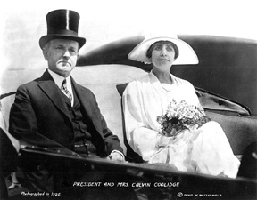
President Calvin Coolidge :
"Wealth is the chief end of man!"

"The man who builds a factory, builds a temple. The man who works there, worships there."

