MIDDLE EAST NEWS

Middle East Strains Under the Weight of Syria's Two Million Refugees
By Nour Malas, September 3, 2013, 8:30 p.m. ET

ZAATARI CAMP, Jordan—With the Syrian refugee numbers passing the two million mark Tuesday, governments and aid officials are coming to the same reckoning as Mohammad Hariri, an air-conditioner repairman who came here for one night and stayed for a year.
"My opinion is now, on the ground and politically, it's going to take a long, long time," he says.
In early August 2012, Mr. Hariri brought his three children across the border to escape some particularly intense shelling. Today, the camp remains his home—along with some 130,000 other Syrians.
"We used to see refugees on television," says Mr. Hariri, who is also a neighborhood camp leader. "We didn't know what it meant to be one."
The camp, Zaatari, now ranks as Jordan's fourth-largest city, the United Nations says, and as the second-largest refugee camp in the world. Only Dadaab in Kenya, with more than 400,000 people, is bigger, the U.N. estimates.
- Why did Mohammad Hariri originally bring his family to Jordan?
- Why is he still there?
- What is the only country with a refugee camp larger than Zaatari?
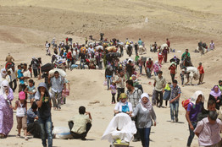
Picture: More than two million people have fled the recent fighting in Syria, and the number of refugees is expected to reach 3.5 million by year-end, U.N. officials said Tuesday. Associated Press

A total 70,095 people mostly from Sudan live in the Yida camp, in the newly independent South Sudan.
"Most refugee camps in the world take decades to populate," says Andrew Harper, the country representative in Jordan for the U.N. High Commissioner for Refugees. Mr. Harper oversees the U.N. aid effort for over half a million Syrians there.
Down the sandy road from Mr. Hariri's home—a trailer paid for by a Saudi businessman whose name is on a steel plate tacked to the wall—at least 30,000 kiosks form a bustling mini-economy run by other Syrian refugees. Between butchers and grocers, there are signs that residents don't see themselves leaving anytime soon: a ladies' salon, a costume store, a wedding-gown shop.
- How many refugees are in the Yida camp?
- What are the signs that show refugees probably won’t leave any time soon?
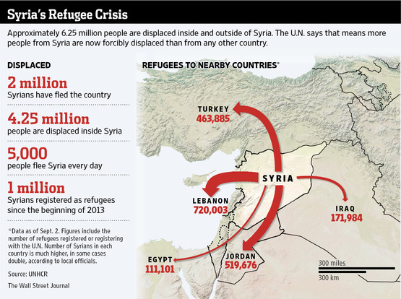
Across the region, Syrian refugees are competing with locals for mid- to low-wage jobs. Within Jordan, Syrians are also taking some work from Egyptian migrants, who are starting to complain. Water has stopped flowing into some northern Jordanian villages for periods of a month or more as demand soars, village residents say.
It is a scene playing out across the Middle East. In Lebanon and Iraq, Turkey and Egypt, Syria's refugee exodus has stretched resources, sparked political and sectarian tensions, and changed economies and demographics.
"We were prepared for 200, 300 people coming per night, but then all of a sudden you started having 2,000, 3,000 people every day," says Mr. Harper of the U.N. "It's been 12 months of continuous humanity crossing into Jordan."
As the threat of U.S. military strikes sends thousands more across borders daily, the refugee crisis has started to ripple beyond the region. The number of Syrians applying for asylum in European Union countries in 2012 tripled, to just over 24,000, from the year before, a European Parliament report said Tuesday.
- In what ways are people from Jordan feeling the strains of resources?
- How many refugees had Jordan prepared to host? How many arrived?
- What areas outside of the Middle East have Syrians applied for asylum (refuge)?
Jordan and Lebanon, Syria's economically weakest neighbors, have become the focus of efforts by the World Bank to help them cope with refugees, including potentially setting up an assistance fund—the first sign that the scope of the crisis has moved from emergency response to development aid. The World Bank said that, at the Lebanese government's request, it is collaborating with U.N. agencies, the EU, and other partners to assess the impact of the refugee influx on Lebanon.
"We're in a chronic situation," says Ted Chaiban, director of emergency programs for the U.N. Children's Fund, "with a wide number of countries affected."
On Tuesday, the U.N. refugee agency—which has called Syria's crisis the worst since Rwanda's—said the number of Syrian refugees surpassed two million, rising by 1.8 million over the past 12 months. Including the 4.25 million more people displaced inside Syria, the agency said, there are more Syrians forcibly displaced than currently is the case with any other country.
- Currently, how many Syrian refugees are there?
Much like with the exodus of Palestinians in 1948 and 1967, neighboring states have absorbed hundreds of thousands of refugees. But they are now recalculating, with the Palestinian experience specifically in mind.
In Jordan and Lebanon—both home to large quasi-permanent Palestinian populations, and now, the bulk of the region's Syrian refugees—officials have over the past three months alternately closed borders to new streams of Syrians or tightened entry restrictions, locals and international aid officials say. The measures reflect a widening concern, officials in both countries say, that the influx may only grow in coming months.
- Why are some countries closing their borders to refugees?
In Lebanon, Syria's fragile and much smaller neighbor, the aid effort has focused nearly as much on helping the host Lebanese community as it has on providing for the refugees themselves. A USAID project, for instance, aims to boost electricity generation in the north so locals don't blame the newcomer Syrians for straining the power supply.
Lebanon is a main route for aid delivery into Syria. So, the closure of borders or the outbreak of war in Lebanon is a particular concern, regional aid officials say.
Tensions have run so high that the government is taking the controversial step of authorizing temporary settlements to better control the refugee deluge from Syria. The move is creating a sticky political debate there: Lebanon remains haunted by its past relationship with refugees—specifically, Palestinians—whose presence in an earlier era played a big role in dragging the country into a 15-year civil war.
- Why are aid groups also trying to help the host countries instead of just the refugees?
"Lebanon has had to surrender to the reality that there is a need for camps," says Wissam Tarif, a human-rights expert who has coordinated the aid response for Syrian refugees in several neighboring countries.
Turkey, which shares the longest border with Syria, has taken in the widest range of Syrians. Impoverished villagers, wealthy businesspeople, ethnic Kurds and military defectors all turned the Turkish border region, and cities farther inland, into a combustible microcosm of the conflict tearing Syria apart.
The latest spillover is a new type of challenge for authorities: disease. Public health services and the water sanitation system have all but broken down in rebel-held northern Syria. As a result, Turkish officials say, they fear the spread of infectious diseases into Turkey from across the border.
"This is difficult," says Ayse Gokkan, mayor of Nusaybin, a Turkish border town. "Diseases don't know of borders."
- What does Gokkan mean by “diseases don't know of borders.”
- How could disease complicate the refugee problem even more?
On Aug. 17, thousands of Syrians trekked over a small bridge usually used to transport goods over a tributary of the Tigris River, which separates Syria from northern Iraq. Weighed down by the mass of Syrian families, the bridge plunged to less than a foot above the water's surface, Mr. Berbihary says.
"We were a moment away from a catastrophe," he says.
Officials closed the crossing to repair the bridge and diverted the refugees to a nearby point at Sahilla. There, however, Syrians must traverse desert plains on foot, or on hired donkeys, from the last Syrian Kurdish checkpoint to Iraqi territory.
On a recent day, in the midday heat, women carried as many as three children apiece and plastic bags full of belongings into Iraq. Stopping first at a table laid with water bottles, they stood in line to dump cold water on their children's reddened faces before moving into a tent set up by the U.N., where they waited for buses to take them to Erbil. They are sent there because Domiz, Iraq's largest camp for Syrian refugees, is already over capacity.
- What hardships are the refugees facing in their journey?
Mr. Berbihary and other officials say the government has diverted 20% of its budget to Syrian refugee aid. But beyond the immediate crisis response, some KRG officials fret the influx is quickly setting up long-term consequences.
At the Kawrgosk camp outside Erbil, patched together last month to host 15,000 Syrians, men leave their wives and children in the tents to work in construction during the day, several families said in interviews. Many said they wanted to start building a new future now, rather than later try to salvage what was left of their war-tattered lives in Syria.
Small children roam the shabby tent settlement, adjacent to a chicken pen and herd of goats. Where there was an open, dusty field two weeks ago, there are now electricity poles, water trucks and a mobile field clinic.
The camp is being expanded to take in another 5,000 refugees, U.N. officials say. Another camp is being built with a concrete foundation and wall "to prevent the chaotic proliferation of living space and families," a local U.N. official says.
- Explain what life is like in Kawrgosk refugee camp.

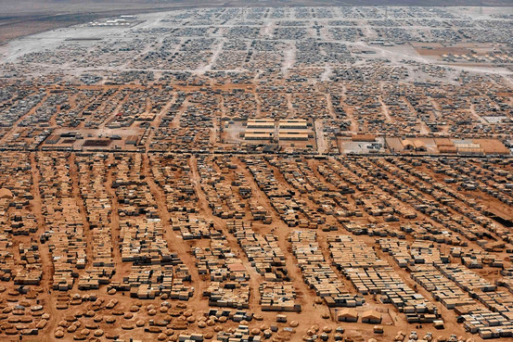
Picture: An aerial view in mid-July of Jordan's Zaatari camp, now home to 130,000 Syrian refugees. Its metamorphosis from tent settlement to full-blown urban community has challenged officials. Reuters

- In your own words, describe the camp in the picture.

Jordan's Zaatari camp is where the metamorphosis from tent settlement to a full-blown urban community has been the most challenging for local government and international aid officials. Syrian refugees like Mr. Hariri, 48 years old, come from large tribes that now populate entire districts in Zaatari. Petty crime is on the rise and hostility runs high toward a Western aid effort seen by Syrians as lacking.
To better manage Zaatari, the U.N. has devised a new plan to administer the camp's 12 quarters through local councils, with the oversight of Jordanian police. Eventually, refugees who run businesses in the camp will be required to pay for basic services like electricity and water. Local leaders like Mr. Hariri, who now oversees 21 streets in an informal arrangement with camp officials, will help administer sections within each quarter.
- What kind of government has been set up in Zaatari camp?
A Jordanian official called Zaatari "a slum" that posed a security threat to the country.
U.N. and other aid officials defend the camp's management, saying it has evolved extraordinarily well given a funding shortfall and the scope of needs from poverty-stricken and traumatized refugees. "It has been a crisis of expectations," a Western aid official at Zaatari says.
On a street in the camp that might seem straight out of an old market in Homs or Aleppo—selling Syrian sweets drenched in syrup, white cheeses, knickknacks of all sorts—Mr. Hariri strolled through, greeting shopkeepers. Zaatari's main market is called the Champs-Élysées, after the famous Paris avenue. Camp officials say it was given the name after French military officials set up a field hospital at one end of the street. Syrians, twisting the name, have taken to calling it the "Cham-s-Elysees," Cham being one name for Syria in Arabic.
Mr. Hariri, recalling his arrival here a year ago, says the camp "started as an experiment." Sand would reach mid-shin, he says, gesturing below his knees. Scorpions and snakes were common sightings, he and other residents say.
Today, he and others are reluctantly settling in. "I remember my neighborhood, my friends, my country, every day. I still remember all this," he says. But at the same time, "We forgot what life is like outside this place. I'm used to living here now."
At the shop selling wedding gowns, store-owner Abu Muhammad says he receives about 20 bride-to-be customers a week. "They used to say they want to wait it out, until the war is over. But no one wants to wait any longer," he says.
—Ali A. Nabhan in Baghdad, Ayla Albayrak in Istanbul and Matina Stevis in Athens contributed to this article.
- What desert animals and insects are present in Zaatari camp?
- What items can be purchased in Zaatari camp?
- Why do you think brides no longer want to “wait out” the war before getting married
Write to Nour Malas at nour.malas@dowjones.com
A version of this article appeared September 4, 2013, on page A1 in the U.S. edition of The Wall Street Journal, with the headline: Middle East Strains Under the Weight Of Civil War's Two Million Refugees.
Assignment
Write a letter to a 9th grader from Syria who lives in one of the refugee camps mentioned in this article. In your letter, make sure you make it clear that you have studied the refugee conflict. You can tell the student about your life in the US, draw comparisons, sympathize, and ask questions. This letter should reflect your knowledge of the situation while also providing encouragement to the reader.
Common girl names: Lilith, Sabeen, Tira, Yalda
Common boy names: Adad, Ashur, Baltasar, Sargon

