Geography: Sudan Secession Worksheet Name: Date:
Geography Standard 2.3a: Explain how the uneven distribution of resources in the world can lead to conflict, competition, or cooperation among nations, regions, and cultural groups.

- Define the following 2 terms and give your source (Webster Online Dictionary, etc.)
- Secede-

- Autonomy-

Go to this website http://www.bbc.co.uk/news/world-africa-12115013 . For each map on the website, explain the differences that exist between Sudan and South Sudan. You will use this information to understand reasons that split the country in two.
- Geography-

- Ethnic Groups-

- Infant Mortality-

- Water and Sanitation-

- Education-

- Food Insecurity-

- Oil Fields-

To fulfill this standard, you need to create a map that shows the natural and man-made features that are located in Sudan and South Sudan. Choose three features to map, and create a key for each topic.
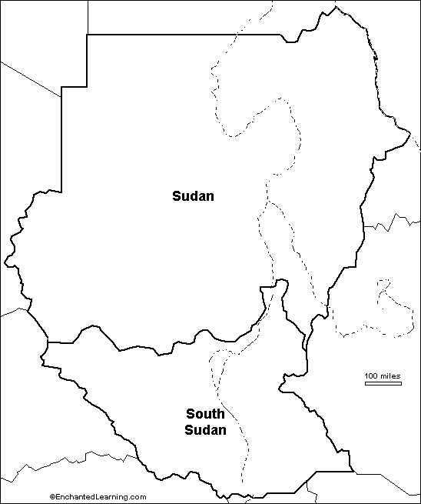
KEY:

Based on the differences you identified in 1-7, what problems might exist for South Sudan after becoming a new country? Write a paragraph response (5-7 sentences) that includes information from the website and map you made to support your reasoning.

