Sparta and Athens Quote Comparison
Quotation 1:
“The fundamental motif through all the centuries has been the principle that force and power are the determining factors. All development is struggle. Only force rules. Force is the first law. . . . Only through struggle have states and the world become great. If one should ask whether this struggle is gruesome, then the only answer could be—for the weak, yes, for humanity as a whole, no. Instead of everlasting struggle, the world preaches cowardly pacifism, and everlasting peace. These three things, considered in the light of their ultimate consequences, are the causes of the downfall of all humanity.”

Quotation 1 most likely describes Sparta/Athens because _________________________________________

_________________________________________________________________________________________

_________________________________________________________________________________________

_________________________________________________________________________________________

Quotation 2:
“We hold these truths to be self evident, that all men are created equal, that they are endowed by their Creator with certain unalienable Rights,* that among these are life, liberty and the pursuit of happiness; that to secure these rights Governments are instituted among Men, deriving their just powers from the consent of the governed.”

Quotation 2 most likely describes Sparta/Athens because _________________________________________

_________________________________________________________________________________________

_________________________________________________________________________________________

_________________________________________________________________________________________

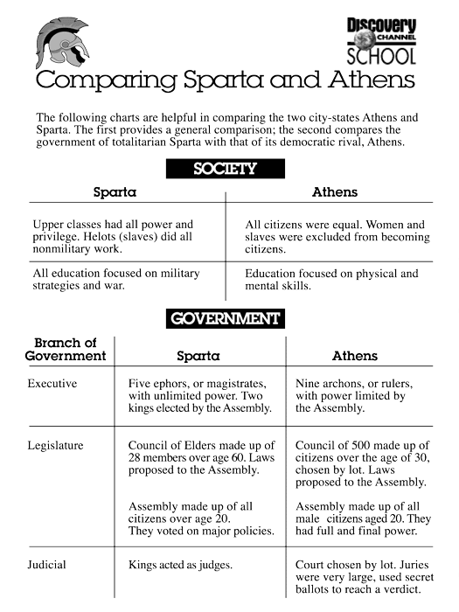
Assignment: During the years 431-404 B.C., Athens and Sparta engaged in wars with one another. Given what you know about the two states, which state do you think was victorious? Defend your choice.

