South Sudan

A new country rises from the ruins

The world’s youngest country struggles to build a decent government and society
May 4th 2013 | LIRIYA |From the print edition
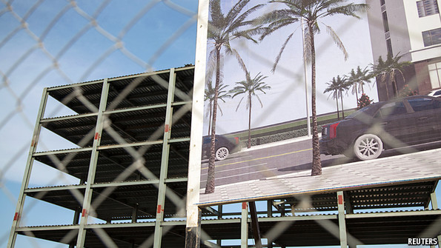
SHOPS and taverns occupy a single row of tin shacks stocked with bottled drinks, the only consumer items available, while a road leading to a dozen thatched huts is still mud. At first sight little has changed in the farming village of Liriya since your correspondent’s last visit two years ago, just before South Sudan’s independence from the northern rump state.
Yet on closer inspection, a few shiny additions come into view at the foot of a lushly forested hill in the country’s south-east (see map). Clusters of houses now share taps of running water from a borehole pumped to an elevated tank. New blue and white school buildings and a vocational training centre have risen amid tilled fields.
Yet such progress amounts to less than it seems, says Charles Sebit, the local priest. Villagers are too poor to buy fuel for the generator powering the water pump when bad weather thwarts solar power. Nor can they afford the school fees from which teachers’ salaries are paid. In any case, the mostly illiterate parents prefer to send their children to the fields or marry them off, hoping for a dowry paid in cattle. Many classrooms are never used.

Much of the hope with which South Sudanese greeted independence in July 2011 has evaporated. Too little has changed for the better. The government’s plans to bring public services to an impoverished population of about 12m, of whom three-quarters are illiterate and innumerate, are stalling. The country is bigger than France but has almost no infrastructure. Less than 1% of the people have access to electricity. “This place makes Afghanistan look developed,” says one of thousands of foreign helpers. Three-quarters of frontline health care is provided by foreign outfits. Without foreign assistance, South Sudan would collapse. Just how independent is it really?

Optimistic officials and do-gooding expatriates insist that change takes time—and is coming. Infant mortality, they say, has dropped from 102 per thousand to a still dire 76. Maternal mortality, at 2,054 per 100,000 births, remains the world’s worst. The country’s first major paved road, from Juba, the capital, to Nimule, on the border with Uganda, was completed last year. But 60% of the population are still cut off for half the year due to floods in the rainy season. Paved roads to connect the main towns of South Sudan’s ten states would cost $7 billion. At present only UN helicopters can be relied on to reach them.

Yet the new country’s potential remains great. It has a lot of oil, more cattle than people, enough farmland to feed most of sub-Saharan Africa, and minerals and timber in abundance. But without roads even the canniest businessmen will struggle to make it worthwhile to invest.
Could the government have done better? The problem is partly systemic. Administrative machinery must be built from scratch. Some 200,000 civil servants have been enlisted. Half are fairly useless: former guerrillas given sinecures to keep the peace. This cannot last. Some 75% of the budget is spent on wages. Every successful liberation movement must eventually discard battle-hardened stalwarts and create competent civilians. South Sudan has a long way to go before reaching that point.
Such huge systemic problems were compounded by a self-inflicted wound when, in January last year, the government shut down oil production. This was in reaction to Sudan, which controls the sole export pipeline and demands fat transit fees for taking much of the output without paying for it. The south bet that the north, seeing its oil revenue fizzle, would buckle first.
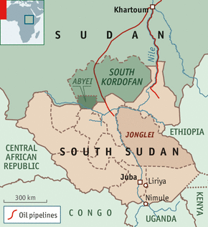
At first South Sudan seemed likely to come off worse. Its formal GDP dropped by 53% last year, says the IMF. Government finance, 98% of it funded by oil, dived. Political leaders focused on the conflict with the north, virtually to the exclusion of everything else. State-building was put on hold. Public resentment rose. Annoyed by a lack of consultation and uncertain of the future, some foreign donors cut funding.

Yet South Sudan’s leadership has been largely vindicated. During the crisis it had to reduce public services even more. But thanks to loans from oil customers and savings from previous budget surpluses, it remained in business. A looming currency collapse was averted. In the countryside, the ancient barter economy kept things going. And in Juba a construction boom continued with private money. Multi-storeyed buildings sprouted in place of pre-independence shacks. Entire districts sprang up. Seen from the air, the city seems to be racing into the surrounding bush. The population may have doubled to about 1.2m in two years. Water lorries with big blue tanks plunge feeder pipes into the Nile at first light, replacing the cyclists who used to go down to river with yellow jerry cans.
Watching from afar, the government in the north eventually blinked, accepting a compromise after little more than a year. The north gets its oil—and fees of nearly $10 a barrel plus $1 billion a year. Southern production resumed on April 7th.

The southern leaders have come out of the shutdown looking canny. They used the crisis to tighten fiscal policy. New revenues were raised; customs receipts tripled. At the same time, southern leaders earned the grudging respect of the north, which had never fully accepted the secession. Omar al-Bashir, Sudan’s president and a notorious bully, learned that the new state will not fail nor will it kowtow. Last month he visited Juba for the first time.

Bothersome borders
All the same, fierce differences with the north persist. In the Sudanese province of South Kordofan rebels allied to South Sudan are fighting Mr Bashir’s forces. A long-running dispute over Abyei, an oil hub on the border claimed by both sides, will be still harder to solve. UN peacekeepers, dampening the tension, will be needed for the foreseeable future. The north has ominously referred to Abyei as “our Kashmir”. At least five other areas along the border are disputed. But both sides are waiting for a report from an African Union panel. If need be, they have agreed to go to international arbitration.

As recent border clashes have shown, such rows need not descend into all-out war. But the south’s own internal security may be even more worrying. Whole communities are traumatised and trust no one after decades of war. Poverty and underdevelopment accentuate ethnic rivalry. The government recently appointed several bishops to head a new commission to oversee reconciliation between warring tribes and factions. In Jonglei state, such tensions have spilled over into open warfare. Since January at least 1,000 people have been killed and more than 100,000 have fled into the bush. “This could undermine everything,” says a foreign monitor. The UN’s 7,000 peacekeepers are essential.

Bad habits picked up during decades of fighting against the north are hard to shed. Officials at all levels seem to indulge an authoritarian streak. Many tend to focus on hurting opponents rather than helping their own people. Human rights are often violated, with arbitrary arrests, summary executions and routine intimidation of journalists. One was sent a bullet and a jawbone as a warning to keep away.

Rivalry between the leading southern tribes, the Dinka and the Nuer, has long been a source of instability. Even in the past few weeks, rumours of friction between the president, Salva Kiir, a Dinka, and his ambitious vice-president, Riek Machar, a Nuer, have jangled nerves in Juba.

In any event, the transition of the ruling Sudanese People’s Liberation Movement from rebel group to national government is incomplete. As winners of the civil war, many veterans feel entitled to spoils. Police outside the presidential palace openly ask for bribes. Last year Mr Kiir sent a letter to 75 senior officials accusing them of embezzling $4 billion. “We fought for freedom, justice and equality,” he wrote. “Once we got to power, we forgot what we fought for and began to enrich ourselves at the expense of our people.”
From the print edition: Middle East and Africa

