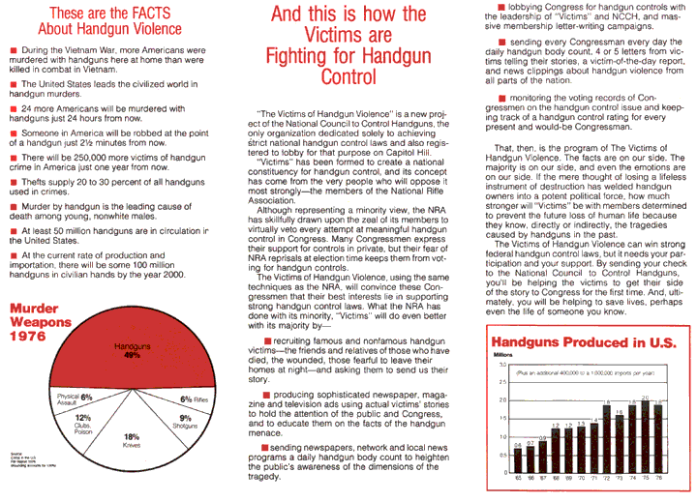
Source: The Brady Center to Prevent Gun Violence (formerly the National Council to Control Handguns)

