1914: The Ludlow Massacre
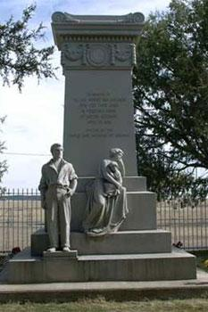
This is the history of the Ludlow Massacre of striking coal miners, one of the most brutal attacks on organized labor in North American history.
Issues concerning labor had plagued the United States for many years preceding World War I, and had resulted in widespread strike action, especially in the Western US. Tensions rose at the Rockefeller-owned Colorado Fuel and Iron Corporation (CF&I) when a union activist was killed in late 1913, leading to a strike.
Miners of CF&I were paid $1.68 a day and were forced to work in extremely harsh conditions. In Colorado, mining fatality rates were often double the national average. Wages were paid to miners in a currency called “scrip,” which was redeemable only at the company store. Members of the United Mine Workers of America (MWA), the worker’s union, were victimized.
When the members of the UMWA went on strike, they demanded the following from CF&I:
“…Recognition of the United Mineworkers of America as the bargaining agent for workers in coal mines throughout Colorado and northern New Mexico, an effective system of checkweighmen in all mines, compensation for digging coal at a ton-rate based on 2,000 pounds, semi-monthly payment of wages in lawful money, the abolition of scrip and the truck system, an end to discrimination against union members, and strict enforcement of state laws pertaining to operators’ obligations in supplying miners with timbers, rails, and other materials in underground working places.”
The demands of the union and the continuing strike enraged the Rockefeller family, which, through mine-ownership, effectively ruled the region. They evicted striking workers from their company-owned homes, leaving them (along with their families) to face the harsh Colorado winter without shelter. UMWA groups across the US helped the strikers organize tent cities close to canyon mouths that led to coal camps in an attempt to block strike-breakers replacing them.
CF&I hired armed guards to harass strikers and union organizers. An armored car with a mounted machine gun was even built which was appropriately named the “Death Special” by company guards. As tensions escalated between CF&I and the strikers, miners dug protective pits beneath their tents to shield themselves and their families against random sniping and gun fire from the company guards. On October 17th, the Death Special was used to attack the Forbes tent colony, resulting in the death of one miner, and various injuries to others. Confrontations between striking miners and scab workers were also resulting in additional deaths. On October 28th, Colorado Governor Elias M Ammons called out the National Guard to take control of the situation.
Union members and organizers were kidnapped and beaten, and endured shots fired into the camps from strike-breakers and the National Guardsmen. Worried about the continuing cost of keeping the National Guard in the field, Governor Ammons accepted an offer from the Rockefeller family to put Rockefeller men in National Guard uniforms.
On March 10th, the body of a strike-breaker was found by the railroad tracks near the Forbes tents, and the General Chase ordered the colony to be destroyed. National Guardsmen were then ordered to evict the remaining tent colonies around the mines, even though they were on private property leased by the UMWA.
The Ludlow tent colony was the largest, and on the morning of April 20th, 1914, troops fired into the camp. The miners fired back, and fighting raged for almost fourteen hours.
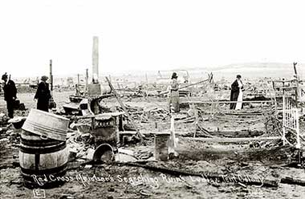
Red Cross workers sift through the wreckage of the strikers' camp after the attack.
In the afternoon, a passing freight train stopped near the camp and allowed many miners and their families to escape East. After many hours of exchanging fire with the militiamen, the mine workers’ main organizer, Louis Tikas met with Lieutenant Linderfelt, the officer in charge of the National Guard assault on the Ludlow camp, to arrange a truce. Linderfelt hit Tikas with the butt of his rifle and soldiers fired several times into his back as he lay on the ground.
That evening, under cover of darkness, the militiamen entered the camp and set fire to tents, killing two women and eleven children who were hiding from the shooting in a pit below a tent. Thirteen other people were also killed during the fighting.
As news of the massacre spread, workers from around the country went on strike to show solidarity with the remaining miners in Colorado and to express sympathy for Ludlow families. Several cities in the state were taken over and occupied by miners, and some National Guard units even laid down their arms and refused to fight.
The mine workers failed to obtain their and many were replaced with non-union workers. No National Guardsmen were ever prosecuted over the killings, even though sixty-six people had been killed by the time violence ended.
In 1918, a monument was erected to commemorate those who died during the strike. These individuals all died in the Ludlow Massacre, and are inscribed on the monument as follows:
Louis Tikas, age: 30 years
James Fyler, age: 43 years
John Bartolotti, age: 45 years
Charlie Costa, age: 31 years
Fedelina Costas, age: 27 years
Onafrio Costa, age: 4 years
Frank Rubino, age: 23 years
Patria Valdez, age: 37 years
Eulala Valdez, age: 8 years
Mary Valdez, age: 7 years
Elvira Valdez, age: 3 months
Joe Petrucci, age: 4 ½ years
Lucy Petrucci, age: 2 ½ years
Frank Petrucci, age: 4 months
William Snyder Jr, age: 11 years
Rodgerlo Pedregone, age: 6 years
Cloriva Pedregone, age: 4 year

Answer these questions in complete sentences in the activities section:
Level 1
- What family owned Colorado Fuel and Iron (CF+I)?
- What were the demands of the workers?
- What offer did Governor Ammons accept?
Level 2
- What is a union and why is it important to workers?
- Were the union workers successful in their strike?
Level 3
- Are unions still useful today? Explain your answer.

