One of the "Lost Boys" found better life in Colorado
Posted: 02/16/2012 01:00:00 AM MST
Updated: 02/16/2012 01:07:19 PM MST
By Monte Whaley
The Denver Post

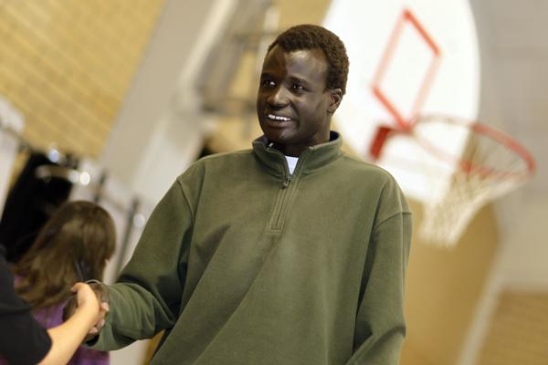
Arok Garang, one of the Lost Boys of Sudan, talks to students from the second, third and fourth grades during an assembly at Sunset Ridge Elementary School in Westminster, Colo., on Wednesday, Feb. 15, 2012. (David Zalubowski, Special to The Denver Post)
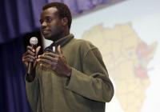
Arok Garang, one of the Lost Boys of Sudan, talks to students from the second, third and fourth grades during an assembly at Sunset Ridge Elementary School in Westminster on Wednesday, Feb. 15, 2012. (David Zalubowski, Special to The Denver Post)
WESTMINSTER — Cold and snow frightened Arok Garang. Cars and trucks made him sick. And American food confused him.
But these things were a small price to pay for the chance to pursue an education in the United States. All that Garang and the other "Lost Boys" wanted, while trying to survive years of deprivation and near starvation in their native Africa, was a shot at improving themselves.
"In Africa, not everyone gets to go to school," Garang said Wednesday. "That's why it's so important for me to go to school, to do better to get that education, to become a leader."
Garang, 30, emphasized the importance of education and leadership to a rapt audience of about 150 third-, fourth- and fifth-graders
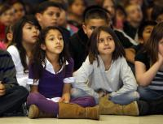
Students listen as Arok Ganang, one of the Lost Boys of Sudan, talks during an assembly at Sunset Ridge Elementary School in Westminster, Colo., on Wednesday, Feb. 15, 2012. (David Zalubowski, Special to The Denver Post)
at Sunset Ridge Elementary. He also asked them to think about the orphans he is still trying to help through the Seeds of Hope organization in Kenya.
"In Africa, children are not being educated," said Garang, who is pursuing a master's degree in economics at the University of Colorado Denver. "But here, you can study and be a leader. Your education will take you very far."
Garang was one of more than 20,000 boys of the Nuer and Dinka ethnic groups driven from their villages during the Second Sudanese Civil War, from 1983 to 2005. Garang, whose parents were killed during a raid on his village when he was 7, walked with other suddenly orphaned children for hundreds of miles over three countries to refugee camps, where they stayed for years.
Garang was able to come to America in 2001 through a program started by the U.S. and the United Nations High Commissioner for Refugees. As many as 3,800 "Lost Boys" made it out and are now spread out over 38 states.
Garang told the Sunset Ridge students that he was a normal kid in southern Sudan, where he helped his parents raise cattle and goats. But that changed in 1989, when government soldiers attacked his tribal village and others.
He and other children ran from the village and walked for three months trying to get to Ethiopia.
"I had to eat anything I found along the way, leaves on trees, anything to keep going," he said.
Many died along the way, mostly from dehydration and eating poison fruit and plants, Garang said.
The children who made it to Ethiopia stayed for 18 months until war again forced them out.
This time, in 1992, they walked to Kenya. After staying at a refugee camp there for nine years, he flew to New York and then to Denver.
"I was sure the coldness would kill me," he said.
He quickly learned that riding in a car or bus made him vomit. Also, he was convinced hot dogs were, yes, cooked dogs. "But, you know," he said, "I've learned to like hot dogs."
Garang now works two jobs to support his education. When Sunset Ridge principal Roger Vadeen first heard Garang's story, he knew his students had to hear it too.
"He pulled himself out of a tough situation," Vadeen said. "His story is so important to hear."
Monte Whaley: 720-929-0907 or mwhaley@denverpost.com

