Geography Standard 2.1.a Gather data, make inferences and draw conclusions from maps and other visual representations
- If you wanted to turn a sphere (3D) into a rectangle (2D), what challenges would you come across?

- People make and use maps for a variety of purposes. Consider some of the different maps you have used. Would a world map be useful in showing how to get from your school to your home? Explain.

Would a city street map be useful in showing the shape of the land (hills, mountains, etc.)? Explain.

- List three similarities and three differences between maps 1-4.
Similarities | Differences

- What happens to the surface of Earth when it is pulled off a globe and flattened?

- How do globe and map projections compare?

- Compare the six projections shown. In which projection does Antarctica appear disproportionately large?

In which projection does Asia appear disproportionately large?
- Record the results from each measurement.
 | Distance between Barrow, Alaska and Miami, Florida | Area of Africa
Cylindrical
Conical
Planar

Which projection minimizes distortion of South America, Africa, and areas near the equator?

Which projection minimizes distortion of the United States?

Which projection minimizes distortion of land in polar regions? Look at Antarctica or Greenland.

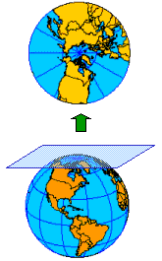 | - Planar Projection  What area of this map is the most accurate?  What area is the least accurate?
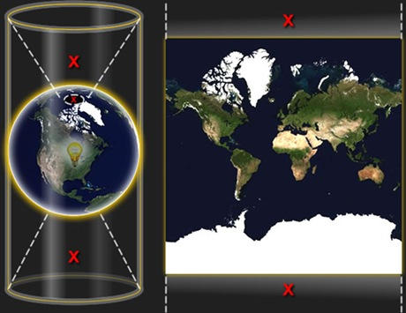 | - Cylindrical Projection  What area of this map is the most accurate?  What parts of this projection are distorted?
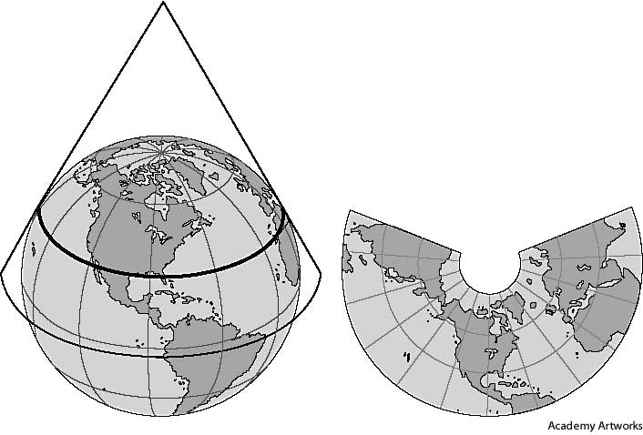 | - Conic Projection  What is a scenario when you might use this map projection?

---------------------------------------------------------------------------
11. Winkel Tripel Projection
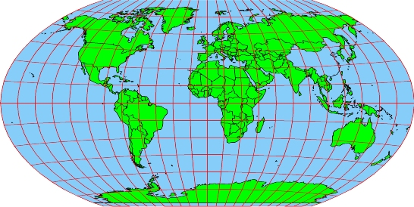
---------------------------------------------------------------------------
12. Robinson Projection
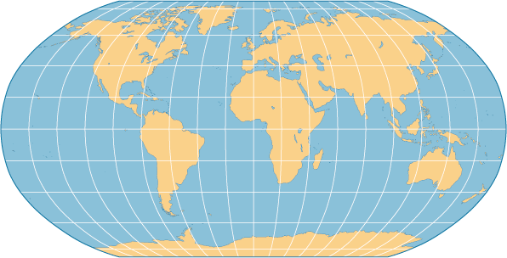
---------------------------------------------------------------------------

13. Goode’s Interrupted Equal-Area
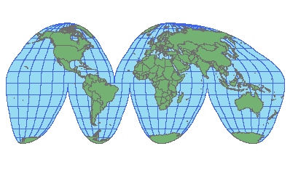
---------------------------------------------------------------------------
14. Mercator Projection
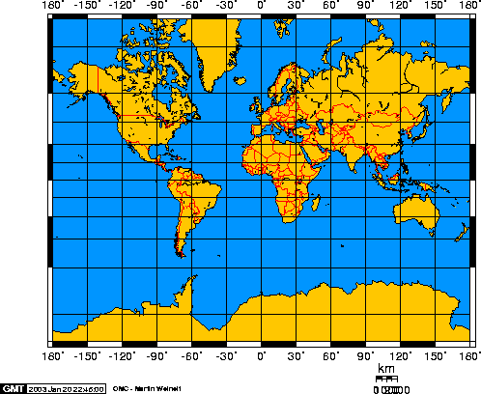
---------------------------------------------------------------------------
Assessment
What do you think is the best map projection for each of the following tasks? Explain your answer.

- Sailing a ship from the southern tip of South America to Australia.

- Driving from San Francisco, CA to Washington, DC.

- Flying from the North Pole to the South Pole.

