Warm-up (complete in your warm-up section):
- List the numbers of the proverbs you have heard before.
- Choose three that you like the most and explain what each means.

Top 20 Wise Quotes Of Confucius
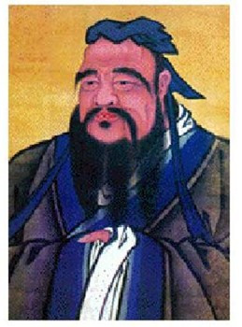
Confucius was a Chinese thinker and social philosopher, whose teachings and philosophy have deeply influenced Chinese, Korean, Japanese, Taiwanese and Vietnamese thought and life. His philosophy emphasized personal and governmental morality, correctness of social relationships, justice and sincerity. This list looks at some of his greatest quotations – all of which are as applicable to us today as they were when he wrote them in the fourth century BC.

1. Everything has its beauty but not everyone sees it.
2. Ignorance is the night of the mind, but a night without moon and star.
3. It does not matter how slowly you go so long as you do not stop.
4. Our greatest glory is not in never falling, but in getting up every time we do.
5. What the superior man seeks is in himself; what the small man seeks is in others.

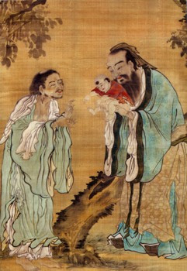
6. They must often change who would be constant in happiness or wisdom.
7. I am not one who was born in the possession of knowledge; I am one who is fond of antiquity, and earnest in seeking it there.
8. If a man takes no thought about what is distant, he will find sorrow near at hand.
9. Learning without thought is labor lost; thought without learning is perilous.
10. Recompense injury with justice, and recompense kindness with kindness.

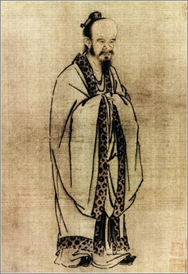
11. The cautious seldom err.
12. The superior man cannot be known in little matters, but he may be entrusted with great concerns. The small man may not be entrusted with great concerns, but he may be known in little matters.
13. The superior man is modest in his speech, but exceeds in his actions.
14. Things that are done, it is needless to speak about…things that are past, it is needless to blame.
15. Virtue is not left to stand alone. He who practices it will have neighbors.

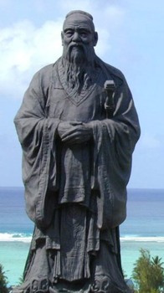

16. What you do not want done to yourself, do not do to others.
17. When you know a thing, to hold that you know it; and when you do not know a thing, to allow that you do not know it – this is knowledge.
18. With coarse rice to eat, with water to drink, and my bended arm for a pillow – I have still joy in the midst of these things. Riches and honors acquired by unrighteousness are to me as a floating cloud.
19. Without an acquaintance with the rules of propriety, it is impossible for the character to be established.
20. To go beyond is as wrong as to fall short.

