A burning cross leaves vision of hatred
By Henrietta Hay
Thursday, March 11, 2010
Grand Junction Sentinel http://www.gjsentinel.com/opinion/articles/a_burning_cross_leaves_vision
One night when I was seven years old I saw a big fire in the house across the alley. My parents and I rushed over and saw a huge cross burning in the middle of south Broadway in front of our friend’s house. Men in sheets and white spiked headdress were marching around and shouting. Our neighbor was a popular doctor and he was also mayor of Englewood. His “crime?” He was Jewish.
Many years later, in high school, I finally understood what had happened that frightful night. The Ku Klux Klan was showing its power and its hatred.
Now, in 2010, as I watch what is going on in Washington, with the Senate in gridlock, I remember the Ku Klux Klan and how powerful it was politically in Denver in 1920. I have been trying to pull together my fragmented memories of the Klan then, its violence and its political strength in Colorado.
A Denver doctor, John Locke, was the Grand Dragon of the Ku Klux Klan in Colorado. He understood Denver’s underlying bigotry well. Negroes (not the word commonly used then, nor is it today) and Jews were expected to stay in their own parts of town. Even the wealthiest Catholics couldn’t buy their way past certain gates.
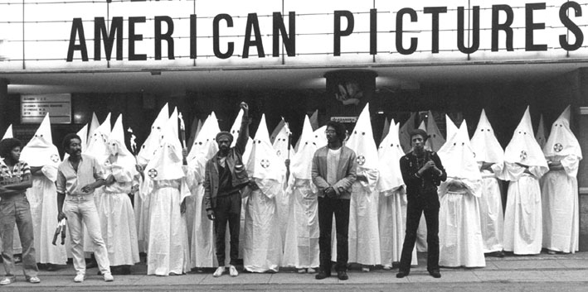
White Anglo-Saxon Protestant males made the rules and ran the show, firmly believing equality was a fine idea if it wasn’t taken too far.
That is the way it was in Denver in 1921. That’s what I, a kid, assumed was the way everybody was. My mother and father were fine, generous people, very active in the community, but they accepted the culture of their times. It was not deliberate bigotry, not prejudice, it certainly was not hatred. It was simply the way things were. We lived in an Anglo-Saxon culture. As I think back I am appalled, and ashamed.
And into that peaceful nest of separation came the Ku Klux Klan to Denver in the early 1920s, ready to take over the state of Colorado. With them the bigotry was quite deliberate. They hated blacks, Jews and the Catholics. So far as I know they still do.
As The Denver Post wrote in 1924, “... the KKK is the largest and most cohesive, most efficiently organized political force in the state.” It secured a variety of political seats, including governor and the mayor of Denver.
The Ku Klux Klan is a racist, anti-Semitic movement with a commitment to violence to achieve its goals of racial segregation and white supremacy.
It is still in existence, defending its vision for white, Anglo-Saxon, Protestant males against all comers.
Of all the types of right-wing hate groups that exist in the United States, the Klan remains one of the largest.
William Sloane Coffin understood it best. “Clearly God is more comfortable with diversity than we are ... After all She made it. We, on the other hand, fear it more than we celebrate it. In fact, diversity may be the hardest thing for a society to live with, and perhaps the most dangerous thing for a society to live without.”
I like to think that we have evolved since 1921, but it is going to take more than 100 years for us to accept universal tolerance toward all human beings. America has become a diverse nation, but too many of us refuse to accept it.
I only know I shall never forget the burning cross or what it stood for. A democratic form of government can’t exist if hatred can overcome civility.

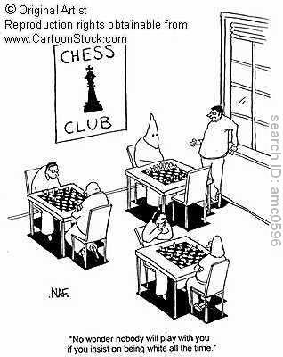

When Colorado was Klan country

History-making 2009 legislative session moves state beyond nationalistic past
By Cara Degette 1/9/09 7:19 AM, The Colorado Independent
http://coloradoindependent.com/19045/when-colorado-was-klan-country
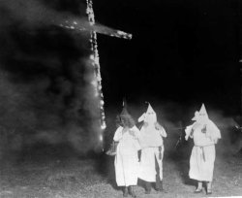This week’s legislative kick-off, with African-American men leading both the Colorado Senate and House of Representatives, is historic indeed, and many have highlighted the import of the moment.
After all, it was less than a century ago that the Ku Klux Klan dominated much of Colorado politics, even claiming then-Gov. Clarence Morley a member. But it would be wrong, as has been suggested in some news reports, to claim that the only targets of the Klan of the early-to-mid 1920s in Colorado were people of color. Rather, as historians have detailed, the primary motivation of the Klan in Colorado was to promote “100 percent Americanism” — and that meant also targeting Jews and Roman Catholic immigrants.
Colorado journalist Ed Quillen is just one historian to detail the rise and fall of the Klan in Colorado politics in an extensive report that appeared in the May 22, 2003 Colorado Springs Independent.
From Quillen’s report:
After the general election of 1924, the governor, Clarence Morley, was a Klansman, taking his orders from Dr. John Galen Locke, the Grand Dragon of the Colorado Realm. Benjamin Stapleton, the mayor of Denver, consulted the Klan when making appointments. U.S. Senator Rice Means was elected with open Klan support. The state House of Representatives had a Klan majority.
Klansmen marched and burned crosses in small towns throughout the state, from Great Plains through the mountains to the Western Slope. A city council, or the mayor’s office, or the police and sheriff’s departments, or the county government — many fell under the Klan’s control.
Numerous cities and towns were infiltrated by Klan activities, Quillen noted, including Denver, Pueblo, Grand Junction and Canon City. “Only one major city escaped,” he noted, and that city was Colorado Springs.
“Then as now, El Paso County was a GOP stronghold,” Quillen reported, “but the party leadership actively opposed the KKK, and the Invisible Empire never gained power at the base of Pikes Peak.”
The Colorado Klan of the 1920s had its racist and anti-Semitic elements, but in Colorado its primary targets were recent Roman Catholic immigrants, especially Italians. They made and drank wine, thereby violating Prohibition and showing disrespect for law and order. They also sent their children to parochial schools, thereby demonstrating that they weren’t rearing their children to be mainstream Americans who went to public schools.
In his book, “A Colorado History,” historian Marshall Sprague noted that Klansmen mainly agitated against immigrants, and encouraged Denverites to only patronize the stores of “real” Americans — and avoid going to restaurants bearing “foreign names, like Pagliacci or Benito or Ciancio or Wong or Torino.”
Once in control of the statehouse, KKK-controlled legislators introduced proposals such as firing all Catholics and Jews on the University of Colorado faculty, and outlawing the use of sacramental wine (which was still allowed under Prohibition). They also pushed to abolish state-sanctioned boards and commissions, and replace them with Klan members.
But that’s not to say violence against blacks did not also occur. Quillen cites author Robert Alan Goldberg, who wrote a definitive book “Hooded Empire: The Ku Klux Klan in Colorado,” detailing several examples of Klan terror, all of which occurred in Denver.
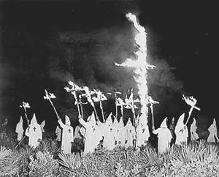In 1922, a black janitor named Ward Gash got a letter from the Denver Klan that charged him with “intimate relations with white women.” He was told to leave town, and “Negro, do not look lightly upon this. Your hide is worth less to us than it is to you.” He turned it over to the district attorney, and left town.
About that same time, Dr. Clarence Holmes, president of the Denver NAACP chapter, started a drive to integrate Denver’s theaters. The Klan burned a cross in front of his office and sent a threatening note, but he persisted.
In the 1920s, Denver blacks attempted to integrate some neighborhoods, and several houses were bombed. But no one was injured. No one was arrested, either, so it was hard to know whether the bombings were from the Klan, or just bigotry in general.
Ultimately, Colorado lawmakers, led by Sen. Billy Adams of Alamosa, managed to prevent the Klan’s legislative agenda (such as repealing Colorado’s civil rights laws) from passing, and the political climate turned against the Klan. Indeed, both Morley and Locke, the Grand Dragon of the KKK, ultimately ended up in jail.
In the end, most of the Klan-sponsored legislative proposals were defeated. “Just two Klan-endorsed bills became state law: one requiring schools to fly the American flag and the other making ownership or operation of (an alcohol) still a felony,” wrote Goldberg.

