Population size of Peary caribou in the Canadian Arctic islands
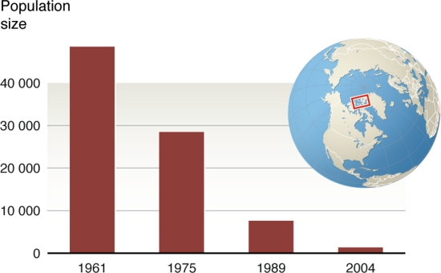
.

- What information does this graph show?
- What is the general trend of caribou populations over the last 50 years?
- Estimate how many more caribou were in the Arctic Islands in 1961 than in 2004.
- Explain the relative location of the Canadian Arctic islands.

Population size of Peary caribou in the Canadian Arctic islands.

In northwestern North America, recent warming has led to a dramatic increase in the number of days of above freezing temperatures during the migration period for the caribou. Thawing and subsequent re-freezing of snow results in ice layers in the snow pack which hinder travel of caribou and make it harder to find food. There have been catastrophic declines in the Peary caribou on the Arctic islands of North America and they are now considered endangered. The formation of ice layers that prevent the caribou from accessing food has been identified as the chief cause of the declines.

- What do you think “catastrophic” means?
- What is the main reason caribou numbers have declined?

Data provided by Don Russell, Environment Canada, Whitehorse, YK, Canada in 2007

Inuit Tapirit Kanatami (ITK). 2008. Inuit in Canada: A Statistical Profile. http://www.itk.ca/sites/default/files/ InuitStatisticalProfile2008_0.pdf [Accessed 22 March 2010].

Arctic sea ice food web - schematic illustration
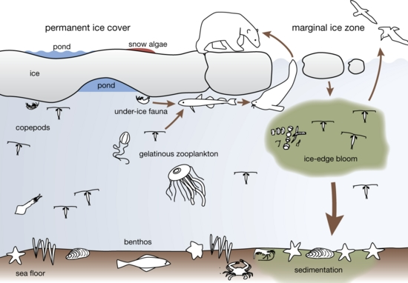

Arctic sea ice food web - schematic illustration.

Sea ice represents a unique ecosystem in the Arctic, providing habitat to specialized ice-associated species that include microorganisms, fish, birds, and marine mammals. Individual species use sea ice in different ways depending on their biological needs. Ice algae form the base of the food web. Some algae stay attached to the bottom of the ice, some fall into the water column, and some fall to the bottom of the sea, and so provide food for species that feed at different depths. Protists (single-celled organisms) and zooplankton eat the algae which are then eaten by, for instance, Arctic cod and sea birds, which in turn act as the major link to other fish and birds, seals, and whales. Polar bears prey upon seals from the ice and walrus forage on clams from drifting pack ice.

- What does “base of the food web” mean?
- What plant forms the base of the food web?
- What do the arrows in the diagram represent?
- What 2 organisms feed on the ice-edge bloom?
- Use the diagram to explain the 4-step food chain for polar bears.
- What do you think would happen if the algae stopped growing?

The Arctic and the World - migration paths
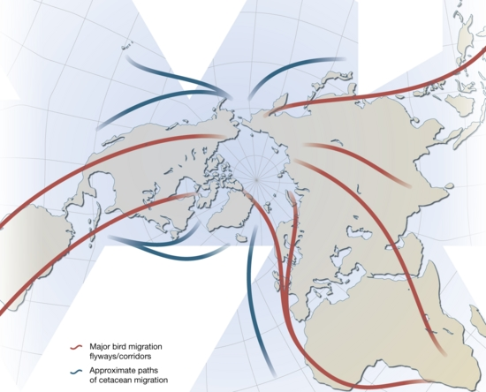

- What information does this chart display?
- What do the red lines represent?
- What do the blue lines represent?
- Why did this cartographer choose this map projection to display this information?

The Arctic and the World - migration paths.

The Arctic plays host to a vast array of biodiversity, including many globally significant populations. Included among these are more than half of the world´s shorebird species, 80% of the global goose populations, several million reindeer and caribou, and many unique mammals, such as the polar bear. During the short summer breeding season, 279 species of birds arrive from as far away as South Africa, Australia, New Zealand, and South America to take advantage of the long days and intense period of productivity. Several species of marine mammals, including grey and humpback whales, and harp and hooded seals, also migrate annually to the Arctic.

- What do you think biodiversity means?
- What are the different animals that live in the Arctic?
- What mammals migrate to the Arctic?
- Why do animals migrate to this area?
Wetlands International. 2009. Flyways: corridors of bird migration. http://wow.wetlands.org/INFORMATIONFLYWAY/FLYWAYCONSERVATION/tabid/173/language/en-US/Default.aspx [Accessed 19 March 2010]. Arctic Tern Migration Project. 2009. Maps for press use. http://www.arctictern.info/carsten/maps.html [Accessed 19 March 2010]. American Cetacean Society. Fact Sheets. http://www.acsonline.org/factpack/index.html [Accessed 19 March 2010].

